Milestone # 2

Introduction

Problem Statement
The goal is to predict the sale price of residential properties based on various features and characteristics of the houses. This prediction will assist buyers, sellers, and real estate professionals in making informed decisions.

Importance of Housing Price Prediction
Buying a home is a significant financial decision, and understanding market value is crucial for buyers to avoid overpaying and to make informed choices. In a fluctuating real estate market, reliable predictive insights empower buyers to negotiate effectively.
For sellers, accurately pricing a home is essential to maximize returns while attracting potential buyers. Overpricing can deter interest, while underpricing may lead to financial losses.
This project aims to develop a predictive model that estimates housing prices based on various property attributes. By analyzing historical data, the model will provide valuable insights for both buyers and sellers, facilitating informed decisions and smoother transactions in the real estate market.

Potential Customers

Home Buyers: Want trustworthy information for smart buying choices and fair price.

Home Sellers: Want to set the right price to attract buyers and get the best ROI.

Mortgage Lenders: Need to evaluate property values to decide on loan amounts & assess risks.

Market Researchers: Interested in studying housing trends and predicting future changes.

Government Agencies: Interested in city planning, housing policies, and economic growth.

Mortgage Lenders: Interested in assessing property values to determine loan amounts & risks

Appraisers: Looking for tools to evaluate property values accurately based on market trends.

Data Selection

Data Source:
The "Advance House Price Predictions" dataset available on Kaggle is a comprehensive collection that focuses on various attributes of residential properties to facilitate accurate price predictions.
https://www.kaggle.com/datasets/zeeshanmulla/advance-house-price-predicitons/data

Importance of the Dataset for Solving the Problem
It includes a wide range of features such as property size, location, zoning classifications, and structural details, which are crucial for understanding the factors influencing house prices.

The dataset is designed to support predictive modeling efforts, making it an excellent resource for data scientists, real estate professionals, and researchers interested in exploring the dynamics of the housing market. By leveraging this dataset, users can develop models that provide insights into market trends and assist in making informed buying and selling decisions.

Project Proposal

Planned Models for Housing Price Prediction
To ensure the best performance for the Housing Price Prediction Model, I will experiment with and analyze various models including (but not limited to)
Random Forest Model: It is an ensemble method that combines multiple decision trees to improve accuracy and reduce overfitting, making it robust for complex datasets.
Support Vector Machines (SVM): It is suitable for high-dimensional spaces, SVM can effectively capture complex relationships in the data.
Decision Trees: It is Useful for capturing non-linear relationships and interactions between variables, providing clear decision rules.
XGBoost: It is known for its speed and performance, XGBoost is particularly effective for structured data and often performs well in competitions.
I have selected these models because they can work well with different types of data and have shown good results in making predictions. Using a combination of simpler and more advanced models will help us explore the data thoroughly and achieve the best results in predicting housing prices.

Evaluating Models
Train-Test Split: Divide the dataset into training and testing sets to ensure the models are evaluated on unseen data.
Cross-Validation: Implement k-fold cross-validation to assess model performance across different subsets, providing a reliable estimate of accuracy.
Performance Metrics
Mean Absolute Error (MAE): Measure the average prediction error and givaccuracy.
Root Mean Squared Error (RMSE): Highlight larger errors, providing a sense of the model's predictive power.
R-squared (R²): Indicate how well the model explains the variance in housing prices.
Residual Analysis: Analyze the residuals to identify any patterns or biases in the predictions, ensuring that the model's assumptions are met.
Model Comparison: Compare the performance of the Random Forest, Support Vector Machines (SVM), Decision Trees, and XGBoost to identify the best-performing model.
Visualization: Use scatter plots and other visualizations to compare predicted vs. actual prices, helping to illustrate trends and identify outliers.
I am planning to assess and compare the chosen models, ensuring the selection of the most effective approach for accurate housing price predictions.

Key Learnings
Key Factors: Understand which features have the most impact on property values
Model Performance: Evaluate which models provide the most accurate predictions for prices.
Data Relationships: Explore how different features interact with each other and affect price. Market Trends: Identify patterns and trends in the housing market based on the data analysis.
Improvement Opportunities: Discover areas where the models can be refined for better accuracy and reliability.
By gaining these insights, I am planning to enhance my understanding of the housing market and improve predictive modeling techniques.

Risk Assessment
Data Quality Risk: Incomplete, outdated, or inaccurate data can lead to poor model performance.
Mitigation: Conduct thorough data cleaning and preprocessing to ensure data integrity.
Overfitting Risk: Complex models like Random Forest and XGBoost may perform well on training data but poorly on new data.
Mitigation: Use techniques like cross-validation and regularization to prevent overfitting.
High-Dimensionality Risk: Support Vector Machines may struggle with very high-dimensional data and lead to longer training times.
Mitigation: Apply dimensionality reduction techniques (PCA), to simplify the feature space
Model Bias Risk: Some models may favor certain features, leading to biased predictions.
Mitigation: Validate if dataset is balanced & evaluate models for bias.
Market Change Risk: Rapid changes in the housing market can make models less relevant.
Mitigation: Regularly update models with new data to reflect current market conditions.
External Factors Risk: External Factors such as economy, interest rate can significantly impact the demand and ultimately the Sale price
Mitigation: Include other features such as Interest Rates, Economic Indicators to account for external factors into Sale Prediction Model
By identifying these risks and implementing mitigation strategies, the proposal can achieve more reliable results and better insights into housing price predictions.

Contingency Plan
Re-evaluate Data Sources: If data quality is an issue, seek alternative datasets or additional sources to supplement missing or inaccurate data.
Simplify Models: If advanced models like XGBoost or SVM do not yield satisfactory results, revert to simpler models (e.g., Linear Regression or Decision Trees) for initial predictions.
Adjust Features: If model performance is poor, reassess the selected features. Consider feature selection techniques to identify the most impactful variables.
Iterate and Refine: If initial models fail, adopt an iterative approach to refine models based on feedback and performance metrics, testing different combinations of features and algorithms.
This contingency plan provides flexible strategies to adapt to challenges that may arise during the project, ensuring continued progress toward effective housing price predictions.
Ethical Consideration
Data Privacy: Ensure that personal information is safeguarded and used responsibly.
Discrimination: Prevent the model from reinforcing existing biases based on race, gender, or socio-economic status.
Transparency: Establish and maintain clear communication about how the model works and its limitations.
Stakeholder Involvement: Engage relevant community members and key decision makers to promote trust and ethical practices.
Feature Engineering
Feature Selection: Identify and select the most relevant features that impact housing prices.
Transformation: Scale numerical features and encode categorical variables to enhance model input.
New Features: Create new features that capture interactions between existing variables.

Milestone # 3

Will I be able to answer the questions I want to answer with the data I have?
Relevance: Features in the Dataset such as Lot Area, House Style, Year Built, Basement Finish Type, Number of Bedrooms, Bathrooms & Garages amongst other are all relevant to answering the problem question and they help gain insights required.
Completeness: Based on my initial analysis, majority of the key features do not have any missing values, this will ensure that steps such as Model Selection, Model Evaluation, etc., are not hindered.
Noise: I am in the process of data cleaning which involves removing irrelevant and less relevant features from the dataset which help reduce the noise and improve the performance and effectiveness of the final model
Quality: As per data assessment exercise, data is of high quality and appear to be reliable.
Dataset contains relevant, complete, and high-quality features, and are appropriate for analytical methods.

What visualizations are especially useful for explaining my data?
Correlation – Scatter Plots can be used to understand the relationship between two continuous variables such as Living Area and Sale Price.
Skewness & Outliers – Histograms can be used to visualize the distribution of continuous variables such as Lot Area, Sale Price, etc.,
Central Tendency/Spread – Box Plots are useful to compare the distribution of target variable, “Sale Price” across various categorical variables such as Building Type, Neighborhood, etc., They also help highlighting medians, outliers and quartiles.
Correlation Coefficient – Heatmap can be used to identify relationships between numerical variables, helping to understand which features are most influential on target variable.

Do I need to adjust the data and/or driving questions?
No, adjusting the data or driving question is not required. The dataset has important features that helps understand the housing market and covers a variety of properties and conditions for solid analysis. My problem statement matches the available data. Adjusting or modifying the dataset may risk losing valuable information that could impact the conclusions.

Do I need to adjust my model evaluation choice?
No, adjusting the models or model evaluation choices are not required. The planned models for housing price prediction, including Support Vector Machines, Decision Trees, and XGBoost, are ideal for the dataset. Also, evaluation strategy including techniques like train-test splitting and k-fold cross-validation, and performance metrics such as Mean Absolute Error, Root Mean Squared Error, and R-squared will ensure thorough assessment of the models’ effectiveness.

Are my original expectations still reasonable?
Yes, the original expectations are still reasonable. The planned models and evaluation strategies align well with the dataset and the problem statement, Housing Price Prediction project. I believe that the strength of the selected models and thorough evaluation methods will help extract meaningful insights and accurate predictions. The well-structured approach and established methodologies, and leveraging it effectively will produce realistic and successful outcomes.

Data Visualization

Correlation
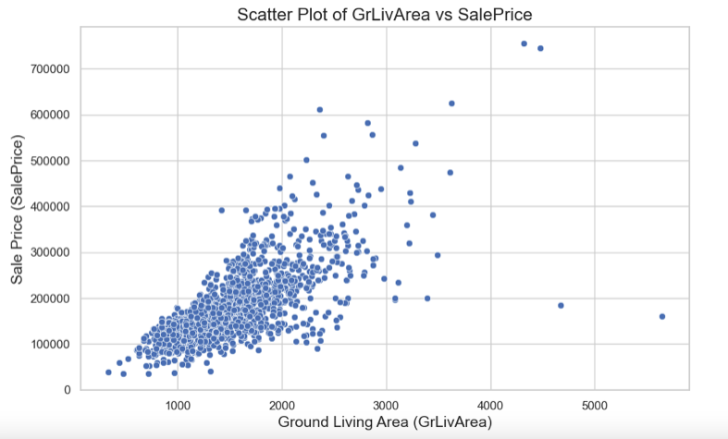

Distribution
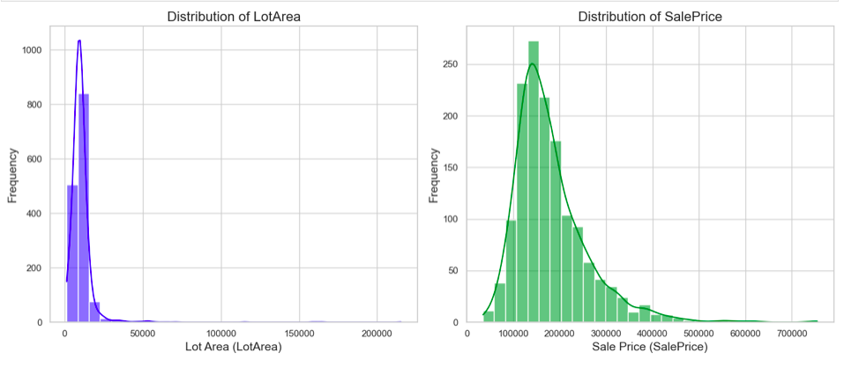

Central Tendency/Spread
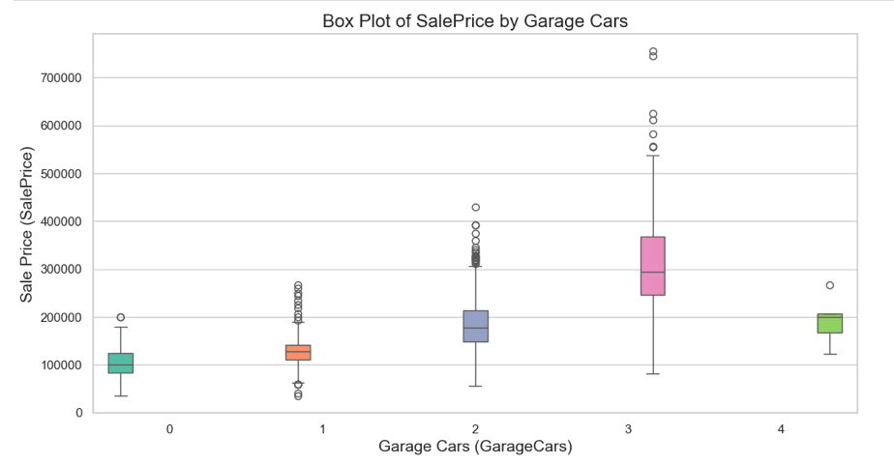

Correlation Coefficient

Milestone # 4

Prepping the Data

Dropping the Columns
I have dropped the columns that are
- Not core to the analysis topic.
- Secondary columns which covers additional dimension [Example: Exterior2nd: Exterior covering on house (if more than one material)] whereas primary features are already available
- Not current (Condition columns such as Basement Condition, Floor Condition indicates the current state where are the Quality columns indicates the quality at the time of installation)
- Not essential (Example: Sale Condition, Screen Porch Area, etc.,)

Encoding Categorical Features
- Performed Binary encoding for the CentralAir column since Maching Learning algorithm works with numerical values
- Performed Ordinal Encoding of Categorical Features which have values that are ordinal in nature. (Example: Kitchen Condition Feature which have values such as Excellent, Good, Fair, Poor, etc.,)
- Performed One Hot Encoding of Categorical Features (that cannot be classified as Ordinal)

Building and Evaluating Models

Random Forest Model
Approach: Split the Training dataset into Training and validation. I have trained the Random Forest Model on the Training data and evaluated the model on Validation data prior to making the prediction in Test Data using Random Forest Model
Evaluation Results:
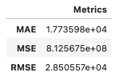
Evaluation Summary:
- The MSE value of 812567505.7272985 indicates that, on average, the squared difference between predicted and actual sale prices is quite large and this suggests that the predictions may not be very accurate.
- This MSE value suggests that the Random Forest model may need tuning or that feature engineering could improve its predictive power.
- Improvements can be made using techniques such as Hyperparameter Tuning, Feature Engineering, Cross-Validation, etc.,
Prediction Results:

Linear Regression Model
Approach: Split the Training dataset into Training and validation. I have trained the Random Forest Model on the Training data and evaluated the model on Validation data prior to making the prediction in Test Data using Linear Regression Model
Evaluation Results:
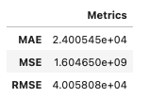
Evaluation Summary:
- Mean Absolute Error (MAE) - On average, the model's predictions deviate from the actual sale prices by approximately 24,005 USD and this metric provides a straightforward interpretation of the average error in dollar terms.
- Mean Squared Error (MSE) - The MSE indicates the average squared difference between predicted and actual values. A higher value suggests larger errors. The magnitude of this value suggests that the model may still have significant room for improvement.
- Root Mean Squared Error (RMSE): RMSE is the square root of MSE and provides an error metric in the same unit as the target variable (dollars). An RMSE of approximately 40,058 USD indicates that, on average, the model's predictions deviate from the actual sale prices by this amount. RMSE is particularly sensitive to large errors, making it a useful metric for assessing model performance.
- The MAE provides a clear view of average prediction errors in dollar terms, while the RMSE highlights how errors can vary, particularly focusing on larger discrepancies.
- Both MSE and RMSE suggest that the model's performance could be improved, indicating that tuning, feature engineering, or other enhancements may be necessary to reduce these error metrics.
Prediction Results:
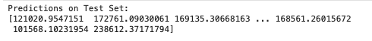

XGBoost Model
Approach: Split the Training dataset into Training and validation. I have trained the Random Forest Model on the Training data and evaluated the model on Validation data prior to making the prediction in Test Data using Linear Regression Model
Evaluation Results:
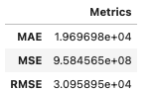
Evaluation Summary:
- Mean Absolute Error (MAE) - On average, the model's predictions deviate from the actual values by approximately 19,697 units. While this provides a straightforward measure of error, the context of the data is essential to assess whether this is acceptable.
- Mean Squared Error (MSE) - The MSE penalizes larger errors more significantly due to squaring the differences. A high MSE suggests that there are substantial discrepancies between predicted and actual values, which may indicate outliers or areas where the model struggles.
- Root Mean Squared Error (RMSE) - RMSE is the square root of MSE, providing an error measure in the same units as the target variable. This value, being quite large (USD 30,958.95), reinforces the notion that there are significant prediction errors that may need attention.
- The values of MAE, MSE, and RMSE suggest that while the XGBoost model captures some trends in the data, there may be underlying issues impacting its accuracy.
- The high MSE and RMSE values could indicate the presence of outliers, which might be skewing the model's performance. It would be beneficial to investigate these further.
Prediction Results:

Interpreting the Results
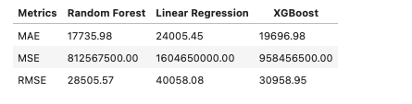
- Mean Absolute Error (MAE): The Random Forest model has the lowest MAE, indicating it performs best in terms of average prediction error.
- Mean Squared Error (MSE): Again, Random Forest shows the best performance with the lowest MSE, suggesting it has the least error when squared, which penalizes larger errors.
- Root Mean Squared Error (RMSE): Random Forest also has the lowest RMSE, reinforcing its strong performance compared to the other models.
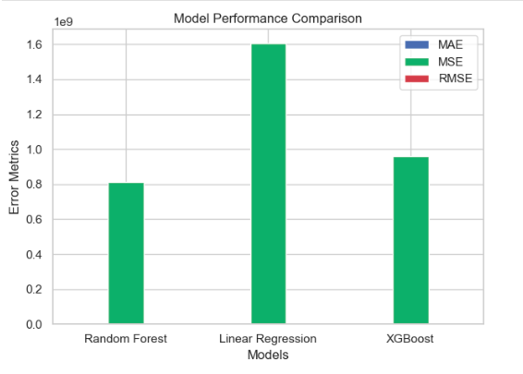
Based on the metrics provided, the Random Forest model outperforms both Linear Regression and XGBoost in all three metrics (MAE, MSE, RMSE), making it the most reliable model for your dataset.

Conclusion
This project has aimed to predict home sale prices using a comprehensive dataset containing various features related to residential properties. The analysis included data loading, cleaning, exploratory data analysis, and preparation for predictive modeling. Upon applying various regression models, including linear regression and tree-based methods, the models demonstrated varying degrees of performance. The evaluation metrics indicated that certain models, particularly ensemble methods, provided better accuracy in predicting sale prices.
- Correlation: A positive correlation exists between the ground living area (GrLivArea) and the sale price (SalePrice). This indicates that larger homes tend to sell for higher prices, highlighting the demand for more spacious living environments.
- Distribution: Both the LotArea and SalePrice distributions are right-skewed. Most properties are concentrated in lower price and area ranges, with few outliers representing larger lots or luxury homes.
This project highlights the importance of data-driven approaches in real estate, offering valuable insights into the factors influencing home prices. By continually refining predictive models and integrating new data, stakeholders can make informed decisions in the housing market, ultimately enhancing investment strategies and market understanding.

Recommendation
- Feature Engineering: Further exploration of additional features or transformations could enhance model performance. Features such as interaction terms or categorical encodings may provide deeper insights.
- Model Optimization: Implement hyperparameter tuning and cross-validation to refine model performance and ensure it generalizes well to unseen data.
- Market Research: Conduct additional analyses to explore geographical trends and neighborhood characteristics that could influence sale prices, allowing for more nuanced predictions.
- Continuous Evaluation: Establish a framework for integrating real-time sales data to keep the predictive model updated, ensuring it reflects current market conditions.

